구조 설계 (System Design)

802.15.4- MAC and PHY
Software Architecture

컴퓨터네트워크 연구실
인제대학교
(초록) 본 문서에서는 … 에 대해 기술한다.

목 차

1 시스템 설계서 (System Design) 4
1.1 개요 (Introduction) 4
1.2 시스템 설계 개념 (Concepts for System Design) 4
1.2.1 용어의 정의 (Definition of Terminologies) 4
1.2.2 설계 개념 (Design Concept) 4
1.3 시스템 구조 설명 4
1.3.1 시스템 구성 (System Architecture) 4
1.3.2 전체적 기능 흐름 (Overall functional flow) 4
1.3.3 세부 기능 (1) (1st function) 4
1.3.4 세부 기능 (2) (2nd function) 4
1.3.5 세부 기능 (3) …. Continued to last function. 4
1.4 구성 요소 설명 (Description of internal components) 4
1.5 시스템 특성 (System Characteristics) 4
1.6 부록 (Appendix, if any) 4

시스템 설계서 (System Design)

개요 (Introduction)
This document defines the software architecture of MAC and PHY conformed with standard 802.15.4 on platform mega128/C2420.

시스템 설계 개념 (Concepts for System Design)

용어의 정의 (Definition of Terminologies)

ZPS | Zigbee protocol stack
PHY | Physical layer
TBD | To be define

설계 개념 (Design Concept)
NA

시스템 구성 (System Architecture)

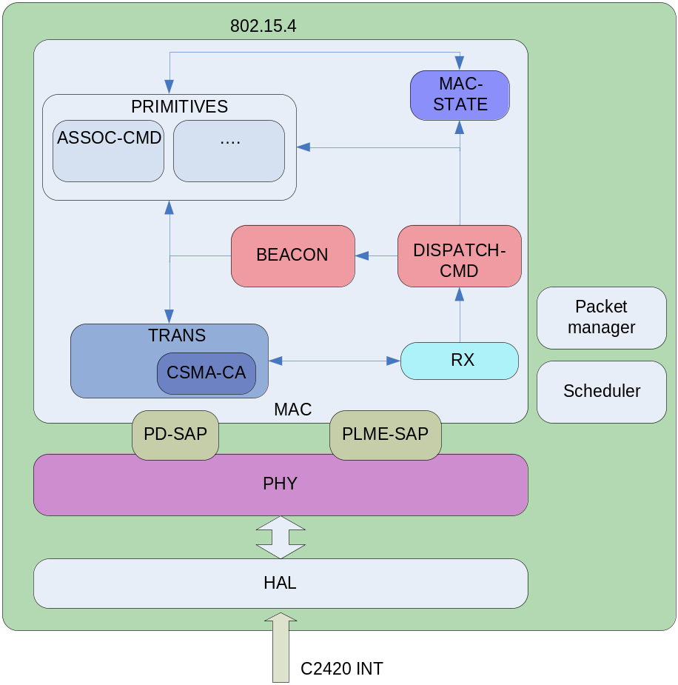
Figure 1: Software architecture of MAC and PHY

HAL | Provide functions to interact with C220
PHY | Provide services as defined in the 802.15.4
Packet manager | Provides services to manage packet used in the MAC and PHY
Scheduler | Schedule task of MAC and PHY
MAC | TRANS | Provides services to transmit packet following procedure of 802.15.4
MAC | CSMA_CA | Provides services to transmit packet using csma-ca defined in 802.15.4
MAC | RX | Received a MPDU from PHY and analyze it, send it to TRANS, if it it ACK or DISPATCH-CMD if others
MAC | MAC_STATE | Manage states (transaction) of the MAC layers.
MAC | PRIMITIVES | Provides primitives as defines in the 802.15.4
Table 1: Component in MAC and PHY

구성 요소 설명 (Description of internal components)

HAL
This component defines function to simplify the interaction with C2420. This component with provides:
- Bit mask to access C2420 pin/register/memory
- Macro to access C2420 pin/register/memory

PHY
This component provides service PD-SAP and PLME-SAP as defined in the 802.15.4. Besides it also provides services to:
- Handle the interrupt to receive packet from C2420
- Control On/Off the transceiver

Packet manager
This component will manage packet used in the MAC and PHY. The services provide by this component will be:
- Packet allocation/de-allocation
- Indirect packet queue management: This function will manage the status of indirect packet queue in the MAC. That includes pushing, pop, and changing status of packet in the indirect packet queue.

Scheduling
This component will provide service to manage the tasks is the MAC. Task here is defined as a routine of source code (function) need to be activated. Task scheduling in MAC must haves following properties:
- Task must have priority. Higher priority task is run first
- For all tasks have the same priority, first in first run.
- Tasks will be activated periodically until it is removed
- Tasks are re-schedulable. Re-scheduled task will be add to the tail of the task queue

TRANS
This component provides services to transmit packet using csma-ca or not using csma-ca. This component will:
- Manage to transmit packet following the procedure in 802.15.4
- Report the status of transmission procedures
- Manage transmission timeout/re-transmission of packet
- Acknowledgment of the sent packet

RX
This component will get the MPDU from the PHY and analyze it. Then
- If the packet it ACK, packet is will be send to TRANS
- If others, packet will be sent to DISPATCH-CMD

MAC_STATE
This component will manage MAC state. That includes
- MLME-GET/SET primitives
- MAC transaction management services

DISPATCH_CMD

This component will dispatch the received command to specific component that process that command.
- Beacon will be dispatched to BEACON
- ACK will be dispatched to TRANS
- Others command will be dispatched to the PRIMITIVES

BEACON
This component will handle function related to beacon:
- Periodically generation of beacon frame
- Process the beacon frame in the beacon network to synchronize the network devices.

시스템 특성 (System Characteristics)

부록 (Appendix, if any)

